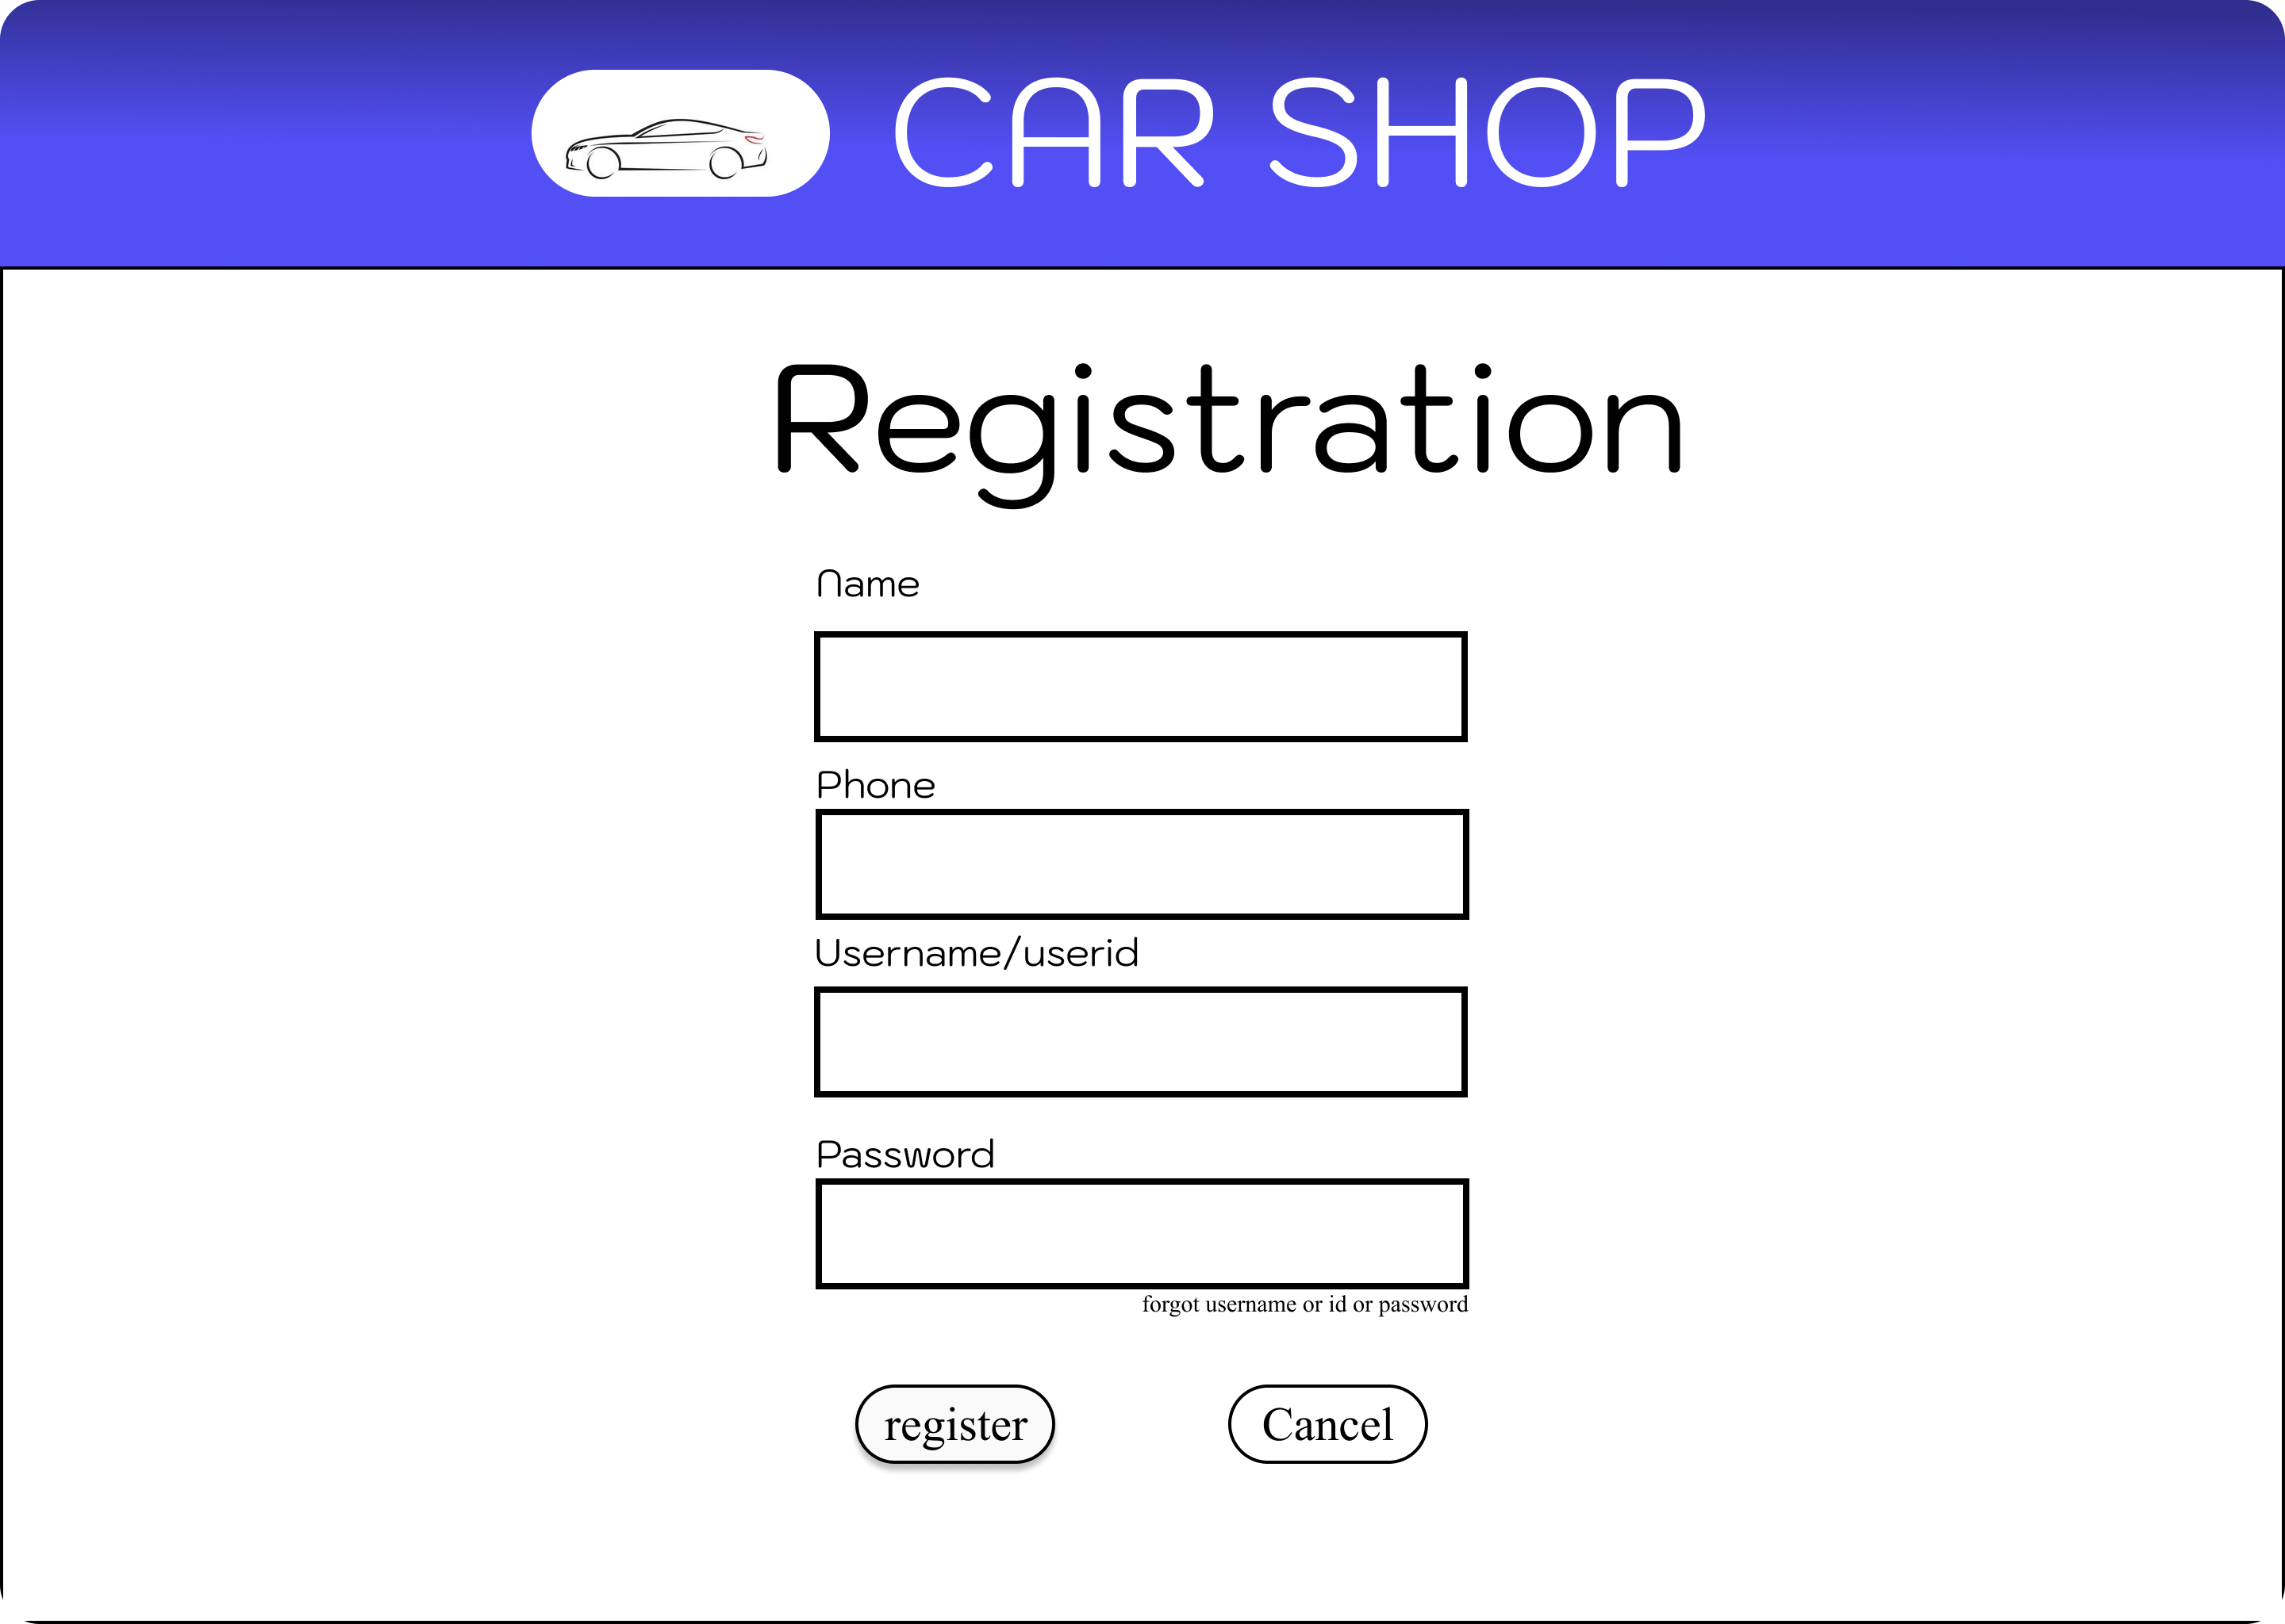

Link:
https://www.figma.com/design/EKRlouWmMujucLii2Fg82g/Car_Shop_Manager_Portal?node-id=202-3&t=idPKcVDRiwm15MgZ-1

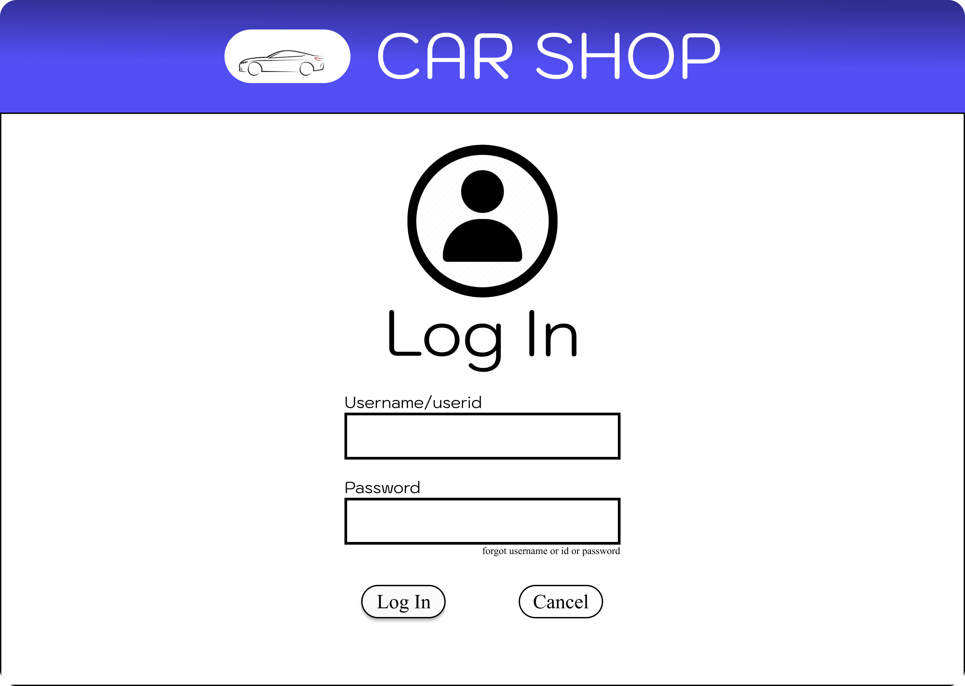
Link:
https://www.figma.com/design/EKRlouWmMujucLii2Fg82g/Car_Shop_Manager_Portal?node-id=202-2&t=idPKcVDRiwm15MgZ-1

